training 1 epoch...

53.39513301849365 seconds used......

1 training finished! average train loss: 0.6268555244855714

evaluating...

Confusion matrix, without normalization

[[ 214 63 17]

[ 552 3177 92]

[ 74 11 757]]

Normalized confusion matrix

[[0.72789116 0.21428571 0.05782313]

[0.1444648 0.83145773 0.02407747]

[0.08788599 0.01306413 0.89904988]]

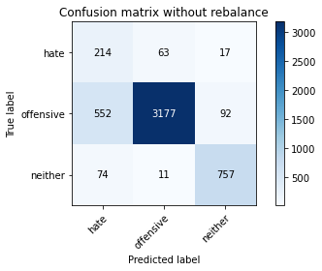

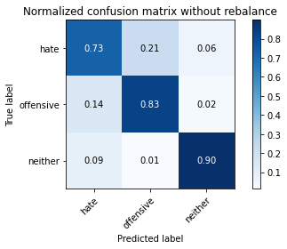

precision recall f1-score support

hate 0.25 0.73 0.38 294

offensive 0.98 0.83 0.90 3821

neither 0.87 0.90 0.89 842

accuracy 0.84 4957

macro avg 0.70 0.82 0.72 4957

weighted avg 0.92 0.84 0.87 4957

average eval_loss: 0.425817929230788, accuracy: 0.8367964494654024

training 2 epoch...

53.45566654205322 seconds used......

2 training finished! average train loss: 0.383511045898654

evaluating...

Confusion matrix, without normalization

[[ 237 45 12]

[ 768 2989 64]

[ 61 45 736]]

Normalized confusion matrix

[[0.80612245 0.15306122 0.04081633]

[0.2009945 0.78225595 0.01674954]

[0.07244656 0.05344418 0.87410926]]

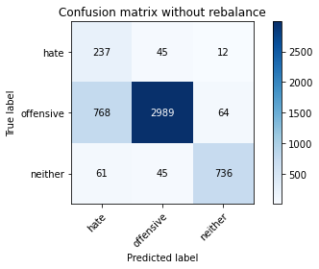

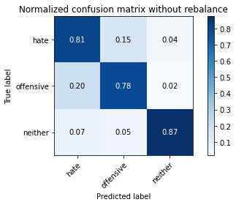

precision recall f1-score support

hate 0.22 0.81 0.35 294

offensive 0.97 0.78 0.87 3821

neither 0.91 0.87 0.89 842

accuracy 0.80 4957

macro avg 0.70 0.82 0.70 4957

weighted avg 0.92 0.80 0.84 4957

average eval_loss: 0.4374632896388405, accuracy: 0.7992737542868671

training 3 epoch...

53.297738552093506 seconds used......

3 training finished! average train loss: 0.2888924421644525

evaluating...

Confusion matrix, without normalization

[[ 200 72 22]

[ 450 3231 140]

[ 25 38 779]]

Normalized confusion matrix

[[0.68027211 0.24489796 0.07482993]

[0.11777022 0.84559016 0.03663962]

[0.02969121 0.04513064 0.92517815]]

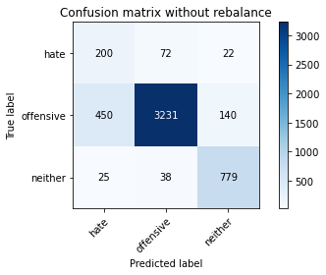

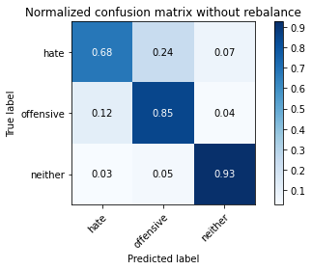

precision recall f1-score support

hate 0.30 0.68 0.41 294

offensive 0.97 0.85 0.90 3821

neither 0.83 0.93 0.87 842

accuracy 0.85 4957

macro avg 0.70 0.82 0.73 4957

weighted avg 0.90 0.85 0.87 4957

average eval_loss: 0.37470487680207387, accuracy: 0.8493040145249142

training 4 epoch...

53.485310316085815 seconds used......

4 training finished! average train loss: 0.20727954959300787

evaluating...

Confusion matrix, without normalization

[[ 233 44 17]

[ 799 2915 107]

[ 44 29 769]]

Normalized confusion matrix

[[0.79251701 0.14965986 0.05782313]

[0.20910756 0.7628893 0.02800314]

[0.05225653 0.03444181 0.91330166]]

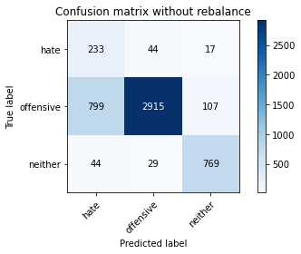

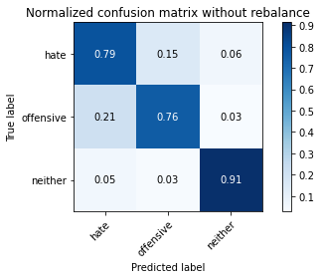

precision recall f1-score support

hate 0.22 0.79 0.34 294

offensive 0.98 0.76 0.86 3821

neither 0.86 0.91 0.89 842

accuracy 0.79 4957

macro avg 0.68 0.82 0.69 4957

weighted avg 0.91 0.79 0.83 4957

average eval_loss: 0.5553982497060677, accuracy: 0.7901956828727053

training 5 epoch...

53.35739064216614 seconds used......

5 training finished! average train loss: 0.10331384832725714

evaluating...

Confusion matrix, without normalization

[[ 232 50 12]

[ 880 2865 76]

[ 65 43 734]]

Normalized confusion matrix

[[0.78911565 0.17006803 0.04081633]

[0.2303062 0.74980372 0.01989008]

[0.07719715 0.05106888 0.87173397]]

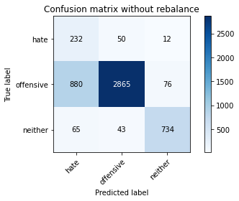

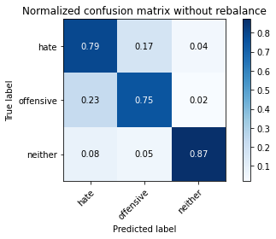

precision recall f1-score support

hate 0.20 0.79 0.32 294

offensive 0.97 0.75 0.85 3821

neither 0.89 0.87 0.88 842

accuracy 0.77 4957

macro avg 0.69 0.80 0.68 4957

weighted avg 0.91 0.77 0.82 4957

average eval_loss: 0.6393773805116532, accuracy: 0.7728464797256405

training 6 epoch...

53.46735215187073 seconds used......

6 training finished! average train loss: 0.07740087266051489

evaluating...

Confusion matrix, without normalization

[[ 192 70 32]

[ 544 3059 218]

[ 21 10 811]]

Normalized confusion matrix

[[0.65306122 0.23809524 0.10884354]

[0.14237111 0.80057577 0.05705313]

[0.02494062 0.01187648 0.9631829 ]]

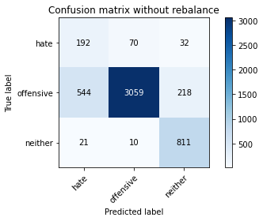

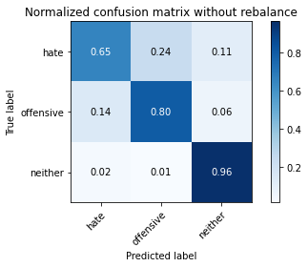

precision recall f1-score support

hate 0.25 0.65 0.37 294

offensive 0.97 0.80 0.88 3821

neither 0.76 0.96 0.85 842

accuracy 0.82 4957

macro avg 0.66 0.81 0.70 4957

weighted avg 0.90 0.82 0.84 4957

average eval_loss: 0.6731633440861506, accuracy: 0.8194472463183377

training 7 epoch...

53.36391258239746 seconds used......

7 training finished! average train loss: 0.0449296278723826

evaluating...

Confusion matrix, without normalization

[[ 249 36 9]

[ 940 2818 63]

[ 93 70 679]]

Normalized confusion matrix

[[0.84693878 0.12244898 0.03061224]

[0.2460089 0.73750327 0.01648783]

[0.11045131 0.08313539 0.8064133 ]]

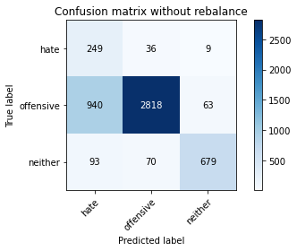

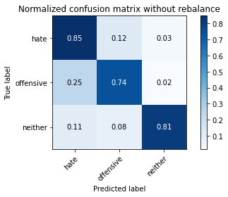

precision recall f1-score support

hate 0.19 0.85 0.32 294

offensive 0.96 0.74 0.84 3821

neither 0.90 0.81 0.85 842

accuracy 0.76 4957

macro avg 0.69 0.80 0.67 4957

weighted avg 0.91 0.76 0.81 4957

average eval_loss: 1.0856571761930638, accuracy: 0.7556990114988904

training 8 epoch...

53.43313431739807 seconds used......

8 training finished! average train loss: 0.035265737719703136

evaluating...

Confusion matrix, without normalization

[[ 240 40 14]

[ 976 2751 94]

[ 60 27 755]]

Normalized confusion matrix

[[0.81632653 0.13605442 0.04761905]

[0.25543052 0.71996859 0.02460089]

[0.07125891 0.03206651 0.89667458]]

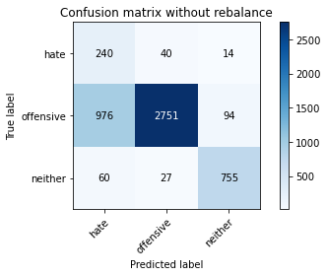

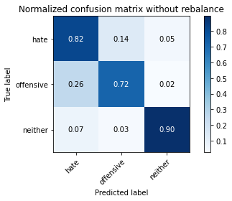

precision recall f1-score support

hate 0.19 0.82 0.31 294

offensive 0.98 0.72 0.83 3821

neither 0.87 0.90 0.89 842

accuracy 0.76 4957

macro avg 0.68 0.81 0.67 4957

weighted avg 0.91 0.76 0.81 4957

average eval_loss: 1.0746783749284814, accuracy: 0.7556990114988904

training 9 epoch...

53.352176904678345 seconds used......

9 training finished! average train loss: 0.01820535478493599

evaluating...

Confusion matrix, without normalization

[[ 257 25 12]

[1489 2265 67]

[ 124 25 693]]

Normalized confusion matrix

[[0.87414966 0.08503401 0.04081633]

[0.38968856 0.59277676 0.01753468]

[0.14726841 0.02969121 0.82304038]]

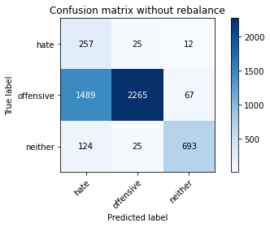

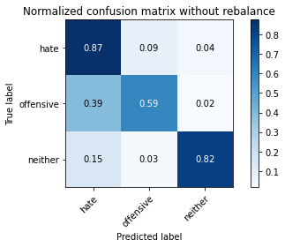

precision recall f1-score support

hate 0.14 0.87 0.24 294

offensive 0.98 0.59 0.74 3821

neither 0.90 0.82 0.86 842

accuracy 0.65 4957

macro avg 0.67 0.76 0.61 4957

weighted avg 0.91 0.65 0.73 4957

average eval_loss: 2.1248020903288958, accuracy: 0.6485777688117813

training 10 epoch...

53.409565925598145 seconds used......

10 training finished! average train loss: 0.02050129563078946

evaluating...

Confusion matrix, without normalization

[[ 206 73 15]

[ 514 3214 93]

[ 46 43 753]]

Normalized confusion matrix

[[0.70068027 0.24829932 0.05102041]

[0.13451976 0.84114106 0.02433918]

[0.05463183 0.05106888 0.89429929]]

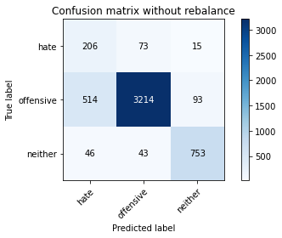

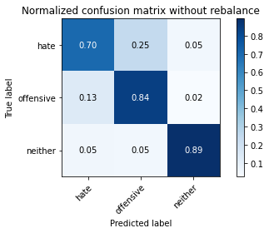

precision recall f1-score support

hate 0.27 0.70 0.39 294

offensive 0.97 0.84 0.90 3821

neither 0.87 0.89 0.88 842

accuracy 0.84 4957

macro avg 0.70 0.81 0.72 4957

weighted avg 0.91 0.84 0.87 4957

average eval_loss: 0.8206172743432358, accuracy: 0.8418398224732702